‘FOEL’
Fun, Outstanding, Enriched Learners
Hwyl, Rhagorol, Cyfoethogi Dysgwyr

Newsletter/Cylchlythyr
Friday 5th November 2025
Dydd Gwener Rhagfyr 5 , 2025

Dear Parent/Guardian/Annwyl Rieni/Gwarchodwyr,
Headteacher’s Update
As we approach the last couple of weeks there is lots going on in school. The children have entered a colouring competition to win £100 of book tokens, they have designed gift boxes and made chocolate truffles to deliver to our local residents as a gift from us. We enjoyed the most delicious Christmas Lunch, many thanks to Becky.
They have also been designing their Christmas Craft to sell at the fair after the concert on Tuesday. They have used a bow saw to learn how to cut a wood cookie in Forest school and these have been turned into a fabulous coaster (not just for Christmas) and a tree decoration. A big thank you to John Heppenstall for helping us turn them into the decorations, he gave up his time to come and teach the children a new glazing technique and to Seb Jones (Thea and Kits dad) for pre chopping the rest of the cookies. They will be on sale after the concert at the bargain price of £5 for both. Don’t forget your cash!
We had a fantastic time at Cinderella at Theatre Clwyd on Thursday. We sang and clapped and laughed and indulged in quite a few sweets too. As always the children were a pleasure to take.
Your child’s Autumn Term report update will be coming out next week, it gives you an insight into their attainment, attitude to learning, attendance details and targets for the Spring Term. Please feel free to contact your child’s teacher if you have any questions.
We will be saying goodbye to Becky in the kitchen next Friday 12th December. She has been with the school for the last 4 years and is a big part of our team. She will be starting a new career at an opticians. We wish her best of luck on this new adventure.

Our Christmas concert this year is ‘Whoops a Daisy Angel.’ And is in the Church – Children will need to arrive at 5:45pm and the concert will start at 6pm. This is will followed by the Christmas fair.
We look forward to seeing you there.
This is the last newsletter of the term, further updates will just be by email.
Have a fantastic Christmas and New Year, rest, recharge and enjoy time with family and loved ones.
See you in 2026. School reopens for children on Tuesday 6th January.
Have a restful weekend.
Warm regards,
Mrs O’Neill

Updated Office Hours

Please note that Mrs Watts office hours have been adjusted as follows:
- Monday to Wednesday: 8:30 a.m. – 12:30 p.m.
- Thursday & Friday: 11:30 a.m. – 3:30 p.m.

Film Night
A chance to go Christmas shopping, child free. The children are welcome to join us in their PJs and bring teds for a film night on Thursday 11th December, with hot dogs and hot chocolate. (film details to follow)

Christmas party day Lunch – Thursday 18th December the lunch will consist of:
- Cheese tomato pizza
- Chicken nuggets
- Sausage roll
- Crisps
- Ice cream tube
There will be vegetarian as well as gluten free options.
If nursery children staying for wrapround care would like a meal this can be ordered on school gateway. The cost of the meal is £2.80.

Governors

We are also in desperate need of a clerk to the governing body. Please contact myself or Mrs Watts for more information.

PTA
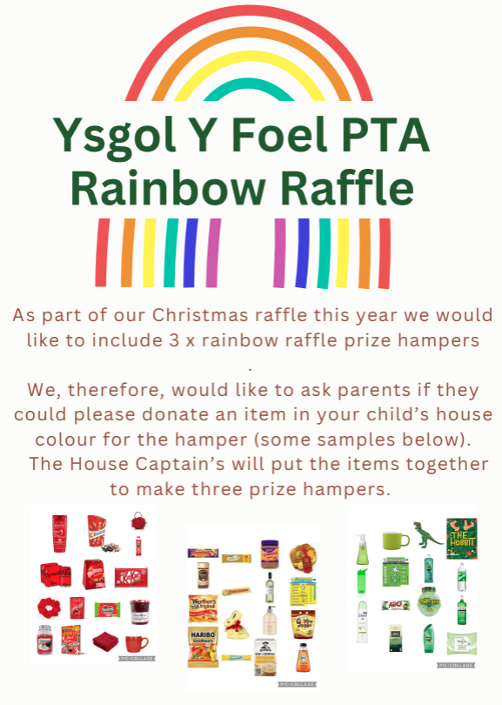

Attendance
- If your child is unable to attend school due to illness, make sure the school office is informed at the earliest opportunity. Late marks will be given to children where they have not arrived before the side gate is closed. Please visit our website where you will find current guidance under Parents and Carers, Sickness and Attendance.
Attendance is compulsory from Reception.
Attendance data for up to 20/11/25:
Class | Percentage of attendance
Dosbarth Famau | 96.35%
Dosbarth Yr Wyddfa | 97.28%
Overall | 96.87%

As a school we strive to ensure our attendance is monitored and your support with this is appreciated. Attendance is a National priority and having met with our designated Education Welfare Officer whose role it is to monitor our attendance and take action if your child’s attendance is below 92%.
Please can you ensure that you either phone 01352 740197 or email the office on yfmail@hwbcymru.net to inform us if your child/ren are not attending school by 9:00am, a reason needs to be provided and when they are likely to return to school. We provide this information to Welsh Government and County Council. If you do not ring in we have to report it as unauthorised.
3-7 learners
In Maths we will continue to work on Number and place value and will be using money in our toy shop.
In Topic we will be covering Wales.
In literacy we will be writing some letters as well as our Christmas Lists!
8-11 Learners
Homework
The children will be set homework each Monday to be returned the following Monday. This will alternate between numeracy and literacy activities.

Spelling will be uploaded onto SeeSaw on a Monday and their test will be on a Friday.
Timetables will be sent home on a Monday to be tested the following Monday.

When we return we will continue to read Treason and the children will be writing playscripts.
In Maths we will be concentrating on times tables, written multiplication and division and some work on length.

Topic we will be covering Japan.

PE
8-11 learners PE will be on a Friday
3-7 Learners will be on Friday

Forest School

Whole school will have Outdoor Learning on Thursday. During their Outdoor Learning session it is important that all children have a change of footwear with them. Please ensure you send your child in appropriate clothing. This means NO Shorts as we often kneel by the fire and in the bushes. Remember Forest School can be messy – wear old clothes!

Breakfast Club/ Out of School Club

All information relating to our Breakfast Club can be found on our website, under Wraparound Care.

Website/ Calendar
Please subscribe to our website, by subscribing you will receive notifications of updates to our website. Don’t forget to subscribe to our calendar as well. This has all the dates of events, residentials etc. to subscribe to our calendar go to www.ysgolyfoel.org click on the full calendar on the right-hand side and follow the instructions at the bottom of the page.

Dates for the Diary (provisional)
Date | Event/ Activity
9/12/25 | Christmas Concerts and Fair times
11/12/2025 | Christmas Jumper Day
18/12/2025 | School closes for Christmas
19/12/2025 | Staff training day
05/01/2026 | Staff training day
06/01/2026 | School opens to children
12/02/2026 | School closes for half term
13/02/2026 | Staff training day
26/02/2026, 27/02/2026 | Year 3 Residential – Conway Centre
27/03/2026 | School Closes for Easter
13/04/2026 | School opens to children
22/04/2026, 23/04/2026 & 24/04/2026 | Year 6 – London Residential
29/04/2026 ,30/04/2026 & 01/05/2026 | Year 4&5 – Plas Menai Residential
22/05/2026 | School closes for half term
01/06/2026 | School opens to children
17/07/2026 | School closes for summer

